Voorbeeld van een examenvraag A-level van AQA (Engeland).
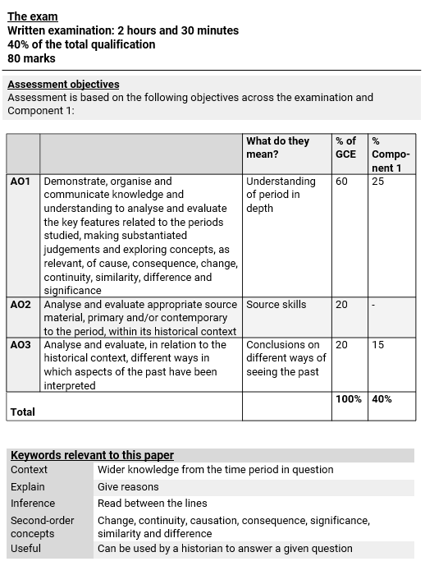

You should spend 2 hours 30 minutes on this section
40% of A-level
80 marks

Section A – Assess how convincing the arguments in these three extracts are … (30 marks)
- Answer Question 1.
- Targets ability to evaluate historical interpretations [AO3].
- The strongest answers will be focused on answering the question using the value of the source and precisely selected knowledge about the historical context.
- Maximum one hour.
Section B – Assess the validity of … (2 x 25 marks)
- Answer two questions.
- Targets understanding of the period in depth [AO1].
- May target concepts (i.e. causation, consequence, change, continuity, similarity, difference, significance)
- The strongest answers will be focused on answering the question using precisely selected knowledge and a well-supported explanation.
- Maximum 45 minutes for each question.
Section A
Answer Question 1
EXTRACT A
“A series of wars technically won but badly bungled in military terms, combined with successive ‘Kaffir,’ Maori, Ashanti, and Afghan campaigns, are evidence of the fitful, halting character of imperial supremacy even in its heyday. Historians have noted the global convergence of multiple imperial crises at particular moments, such as 1879, when the Zulu War and second Afghan campaign were underway and Egypt and the Sudan were heading toward uprising, or 1919, which witnessed a variety of conflagrations, political, economic, and epidemiological that followed on from the Great War. As important as these convergences were for the making of British imperial insecurity, so, too, were regular, local eruptions of protest and resistance at the edges of formal battle. This kind of guerilla fighting meant that military victory was often partial and that contests for territorial expansion were ongoing. Security remained elusive, in short, and maintaining peace was an ongoing task.”
Adapted from Antoinette M. Burton, The Trouble with Empire, published 2015.
EXTRACT B
“The rapidity with which decolonisation occurred between 1945 and 1967 suggests that while decolonisation was the product of changes at the international, domestic British and colonial levels, it was the international ones — particularly the Second World War — that triggered further changes that destroyed old pre-war relationships of the imperial powers with their empires. In the British case, involvement in the war drove them to changes in colonial policy that created new political conditions which made the colonies harder to rule. Meanwhile the international and domestic British side effects of the war (especially the emergence of the anti-colonial powers, USA and the Soviet Union) encouraged colonial resistance to old colonial powers. It made it harder for the British to reassert authority without imposing unwelcome financial and political burdens on the home government, as well as jeopardising wider international interests outside the Empire. A ‘vicious circle’ of imperial decline was set in motion, and the imperial system unravelled.”
Adapted from John Darwin, Britain and Decolonisation, published 1988.
EXTRACT C
“The story of the British Empire's war, therefore, is one of Imperial success in contributing toward Allied victory on the one hand, and egregious Imperial failure on the other, as Britain struggled to protect people and defeat them, and failed to win the loyalty of colonial subjects.”
Adapted from Ashley Jackson, The British Empire, 1939–1945, published 2015
Q1. Using your understanding of the historical context, assess how convincing the
arguments in these three extracts are in relation to the contraction of the British Empire between 1914 and 1967.

Section B
Answer two questions
Q2. To what extent were there changes in the Indian administration despite the failure of the Indian Mutiny in 1857?
Q3. ‘The Scramble for Africa was driven by trade and territorial expansion.’
Assess the validity of this view.
Q4. ‘The Second World War confirmed that Britain was no longer the great power it had once been.’
Assess the validity of this view.

Chosen question number:

Antwoordmodel
SECTION A
Answer Question 1.
Q1. Using your understanding of the historical context, assess how convincing the arguments in these three extracts are in relation to the contraction of the British Empire between 1914 and 1967
30 marks
Points covered to achieve full marks (not limited to what is provided here)
- In identifying the argument in Extract A, the following may be referred to:
  - Britain’s imperial supremacy was threatened even at its peak by a series of wars, and imperial crises were evident in 1879 and 1919.
  - Local upsurge of protest and resistance also jeopardised the security of the British Empire.
  - Maintaining peace in the British territories became a relentless task.
- In assessing the extent to which the arguments in Extract A are convincing, the following may be cited:
  - Britain declared war on behalf of the whole Empire in alliance with France, Russia, and from 1915, Italy, against Germany, Austria-Hungary and Turkey. At the time, the British Empire stood atop the greatest empire history had ever seen.
  - After more than four years of the First World War, colonial rule began to be ideologically challenged.
  - Nationalist movements and demands for separate representation (Dominions) and self-government (colonies) became prominent.
  - The Dominions each demanded separate representation at the Paris peace conference in 1919. Meanwhile, the costs of the war burdened the Indian population. The British position in India began to spin out of control.
- In identifying the argument in Extract B, the following may be referred to:
  - The Second World War was significant to British decolonisation.
  - Old pre-war relationships between Britain and the nations in the Empire dramatically changed as colonies gained independence and as the Commonwealth of Nations was created.
- In assessing the extent to which the arguments in Extract B are convincing, the following may be cited:
  - When the Second World War ended, movements in the colonies demanding independence from the British Empire emerged, threatening the stability of the imperial government.
- In identifying the argument in Extract C, the following may be referred to:
  - The British Empire substantially contributed to Allied victory in the world wars.
  - The world wars had a damaging impact on the British Empire.
- In assessing the extent to which the arguments in Extract C are convincing, the following may be cited:
  - The idea of decolonisation appeared in the interwar period. Decolonisation, notably after 1945, is the dismantling of European empires, and the emergence of sovereign nation-states in Asia, Africa and the Caribbean.
  - Britain was not the only one affected by this process, which meant that British decolonisation was part of a wider international phenomenon.
  - The total war inflicted significant economic damage to the imperial wars. The prolonged colonial wars and campaigns against insurgent nationalist movements proved too costly and impractical.
  - The United States and the Soviet Union held the balance of global power after the Second World War. The new dominant powers both opposed the old-style European imperialism. Since colonial powers were heavily dependent on the US for defence and economic support, they were disposed to American pressure to hasten decolonisation.
  - Movements in the colonies demanding independence from European powers appeared, threatening the stability of the imperial governments.
  - Western Europe saw a dramatic post-war economic recovery by the 1950s. This meant that colonial support became less significant. Furthermore, the creation of European Economic Community in 1957 helped direct trade within Europe itself. Consequently, support for the empire weakened in all the main European imperial powers.
  - Decolonisation was not immediate since Britain and other imperial powers did not quickly withdraw from their colonies. The empires’ granting of independence and withdrawal from territories came in response to specific problems in those territories.
  - Britain generally took on a policy of peaceful disengagement from its colonies between 1947 and 1967.
1st level 1-6 marks 2nd level 7-12 marks 3rd level 13-18 marks
4th level 19-24 marks 5th level 25-30 marks
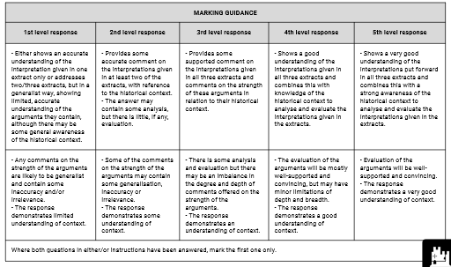
SECTION B
Answer two questions.
Q2. To what extent were there changes in the Indian administration despite the failure of the Indian Mutiny in 1857?
25 marks
Points covered to achieve full marks (not limited to what is provided here)
- The Indian Mutiny of 1857, also known as Sepoy Mutiny or Indian Rebellion, was an unsuccessful uprising in India against rule by the British and the EIC. The rebellion began on 10 May when sepoys, or Indian soldiers serving under British orders, refused to use new rifle cartridges, which were thought to be lubricated with pork and beef fat and thus religiously impure for Muslims and Hindus. The sepoys mutinied in the garrison town of Meerut. Other mutinies then erupted in surrounding areas. It was estimated that between 6,000 and 40,000 Europeans were killed whilst 150,000 Indians were killed with 60% being civilians.
- Whilst the sepoys had failed in their aims in the Indian Mutiny of 1857, huge changes in the Indian administration were introduced following the rebellion. These changes were brought about by the enactment of various Parliamentary acts.
- The British government was forced to pass the Government of India Act 1858 on 2 August 1858. It was followed by Queen Victoria's proclamation to the “Princes, Chiefs, and People of India” on 1 November. The act, among other things, ended the rule of the EIC and ushered in a new period of Indian history, popularly known as the British Raj.
- The Royal Proclamation in 1848 declared the future policy of British rule in India. Announced by Lord Canning, Queen Victoria assured the Indian princes that their territories were not to be annexed by the British government. The proclamation recognised Indians as British subjects and extended to them rights consistent with that status. Hence, it was widely heralded by Indian subjects as their Magna Carta until 1917.
- Another important landmark in the constitutional and political history of India was the passage of the Indian Councils Act 1861. The act gave way to the restructuring of India’s Executive Council and the participation of Indians in the legislative process.
- In 1876, the Royal Titles Act was passed. The act was a gesture to join the monarchy with the Empire further and bind India more closely to Britain.
- Under Viceroy Ripon from 1880 until 1884, some remarkable changes were made in the administrative system of India and legislation that sought to provide popular and political education to the Indians was introduced. Several significant measures were also carried out during the viceroyship of Lord Curzon from 1898 to 1905.
- Constitutional changes were then introduced in 1909 in the form of the Morley-Minto Reforms. Also known as the Indian Councils Act 1909, the acts brought about an increase in the involvement of Indians in the legislature after they showed dissatisfaction with the difficulty of entering into the civil service. Concession for representation was granted to the native elite.

1st level 1-5 marks 2nd level 6-10 marks 3rd level 11-15 marks
4th level 16-20 marks 5th level 21-25 marks

Q3. ‘The Scramble for Africa was driven by trade and territorial expansion.’
Assess the validity of this view.
25 marks

Points covered to achieve full marks (not limited to what is provided here)
- The international developments, as well as fears of military escalations in Europe, resulted in the two conferences that dictated Europeans’ ‘spheres of influence’ and control over African territory, such as the Brussels Geographic Conference of 1876 and the Berlin Conference of 1884 to 1885. The scramble for Africa began in the 1880s.
- The Brussels Geographic Conference of 1876 concluded that:
  - European intervention was necessary in Central Africa since Africans were incapable of developing the natural resources there.
  - The routes to Africa’s great lakes needed to be developed with the construction of roads and railways.
  - An International African Association should be formed to coordinate Europeans’ efforts.
- Meanwhile, the Berlin Conference, 1884-5 is often considered the beginning of the partition of Africa. The conference aimed to secure agreement that both the basins and the mouths of the Congo and Niger rivers were to remain neutral and open to trade. It concluded with the signing of a General Act that stipulated that:
  - All nations should be allowed to trade in the basin of the Congo and its outlets.
  - Free trade should be guaranteed in the regions.
  - The powers with influence in the area should help protect the indigenous peoples and suppress the slave trade and should support and protect religious, scientific or charitable undertakings, Christian missionaries, scientists and explorers.
  - The signatories of the Act should be notified if any power took possessions of further land on the coasts of Africa, in order to enable them to assert their own claim.
- The General Act further provoked a scramble for territory across Africa. By 1900, 90% of the continent was under European control.
- Whilst the Berlin Conference and the subsequent General Act were a success in terms of European relations since European countries were able to expand their empires without war, the lack of African representation at the conference did little to the indigenous populations.
- Natural borders, or ethnic, linguistic or religious division, and the well-being and religious customs of the locals were overlooked. This posed serious postcolonial ramifications for the continent.
- During the scramble for Africa, Britain occupied or annexed Egypt, the Sudan, British East Africa, British Somaliland, Southern and Northern Rhodesia, Bechuanaland, Orange Free State and the Transvaal, Gambia, Sierra Leone, Nigeria, British Gold Coast and Nyasaland.
- Whilst trade and territorial expansion were the common factors that pushed the European countries to assert their claims in Africa, British annexation and occupation of Africa in the 1880s was driven by the following:
  - Britain wanted to maintain its lines of communication with India; hence control over Egypt and South Africa was upheld.
  - Imperialists like Cecil Rhodes encouraged the acquisition of further territory in Africa with the intention of developing a Cape-to-Cairo railway.
  - Britain was interested in the commercial potential of mineral-rich territories like the Transvaal. The Transvaal was established largely by Dutch/Afrikaans-speaking settlers known as the Boers in 1852, and Britain first conquered it in 1877. The First Anglo-Boer War of 1880-1881 ended in Boer victory, however, the Transvaal remained under British influence. The discovery of gold in 1886 intensified British interest in the territory.

1st level 1-5 marks 2nd level 6-10 marks 3rd level 11-15 marks
4th level 16-20 marks 5th level 21-25 marks

Q4. ‘The Second World War confirmed that Britain was no longer the great power it had once been.’
Assess the validity of this view.
25 marks
Points covered to achieve full marks (not limited to what is provided here)
- When Britain declared war on Germany in September 1939, the Empire controlled to varying degrees several colonies and protectorates, and maintained unique political ties to four of the five independent Dominions — Australia, Canada, South Africa, and New Zealand — as part of the British Commonwealth.
- The Empire and Commonwealth had substantial contributions to the war effort during the Second World War.
- Following Adolf Hitler’s suicide in April 1945, the surrender of Germany was authorised by his replacement, Karl Dönitz, and was ratified on 8 May.
- The Allies formally accepted this unconditional surrender. On 15 August, Japan also surrendered, effectively ending the Second World War.
- Far from standing alone, Britain depended on the people, land and resources of its Empire to continue fighting during the war. Once again, the Empire’s contribution was key to the British victory.
- However, by 1945, Britain was exhausted, and its resources were stretched. The British government had to reconsider its capacity to sustain a global empire.
- Additionally, the loss of Singapore to the Japanese shattered the myth of British superiority over non-whites. This encouraged nationalist groups in Africa and Asia.
- Under Clement Attlee's newly elected government, colonies became an expensive liability. At the same time, colonialism was becoming less politically viable.
- The United States’ growing global influence and opposition to imperialism negatively affected the popularity of colonialism.
- In practice, American anti-communism prevailed over anti-imperialism, thus, the US remained supportive of the continued existence of the British Empire to keep Communist expansion under control.
- However, it became evident that the Second World War triggered the end of the British Empire.

1st level 1-5 marks 2nd level 6-10 marks 3rd level 11-15 marks
4th level 16-20 marks 5th level 21-25 marks
